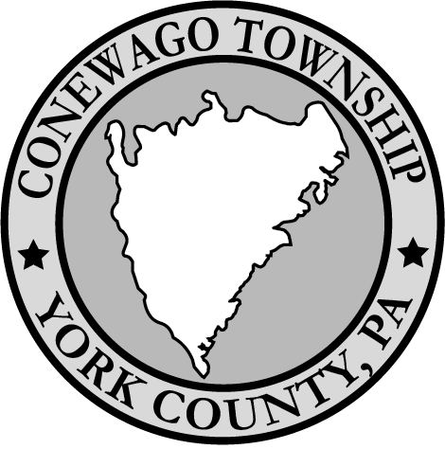
Conewago Township Planning Commission Agenda
Monday March 24th, 2024

Call meeting to order 6:00pm
Pledge of Allegiance:
Approval of the minutes of previous meeting, as distributed:
-Recognition of public requests:
- (5 minutes maximum per person-20 minutes maximum per meeting) This time is allotted for all public comments, including all business listed on the agendas. Please give your full name and address. Please direct your questions to the Chairman. Allow time for other people to ask questions by making your question specific and brief.
-Old Business:
Review the draft with suggested edits of the Multi-municipal Comprehensive Plan.

-New Business:
- Review and comments on the Conewago Township Ordinances #117 Accumulation
- Review and comments on the Conewago Township Ordinance #201 Alarms.
- Review and comments on the Conewago Township Ordinance #233 Soliciting.
-General discussion of other existing Ordinances.

Adjournment:

